

Foundations of Programming

Assignment No.: 15
PROBLEM STATEMENT: Write a C program to generate pseudo random numbers.

OBJECTIVE:

- To understand the concept of pseudo random numbers.
- To learn the use of rand() and srand() functions in C.
- To generate random numbers using the standard library.
- To understand the role of header files in C programming.

THEORY:
In C programming, pseudo random numbers are generated using the rand() function available in the stdlib.h header file. These numbers are not truly random but are generated using a deterministic algorithm. The srand() function is used to set the seed value for random number generation. Usually, the current time is used as a seed to produce different sequences of numbers each time the program runs.

ALGORITHM:
Step 1: Start
Step 2: Include stdlib.h for rand, srand and time.h.
Step 3: Seed random number → srand(time(NULL))
Step 4: Assign result of rand() to a range variable.
Step 5: Define range i.e. min and max.
Step 6: Use formula (rand() % (max - min + 1)) + min
Step 7: Display result.
Step 8: Stop.

FLOWCHART:
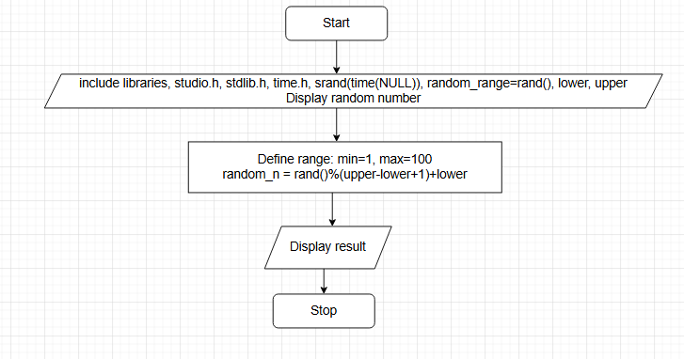

CODE:
#include <stdio.h>
#include <stdlib.h>
#include <time.h>

int main() {
// Seed the random number generator using the current time.
// This should only be called once in the program.
srand(time(NULL));

// Generate a random integer between 0 and RAND_MAX
int random_num_full_range = rand();
printf("Random number in full range (0 to RAND_MAX): %d\n", random_num_full_range);

// Generate a random integer in a specific range (e.g., 1 to 100)
// The formula is: (rand() % (max - min + 1)) + min
int min = 1;
int max = 100;
int random_num_range = (rand() % (max - min + 1)) + min;
printf("Random number in range [%d, %d]: %d\n", min, max, random_num_range);

return 0;
}
PLATFORM: Linux

INPUT: 5

OUTPUT:
183746
928374
567382
345678
987234

CONCLUSION: Thus, the C program successfully generates pseudo random numbers using the rand() function and srand() for seeding.

FAQs:
- What are pseudo random numbers in C?
- Which function is used to generate random numbers in C?
- Which header file is required for rand() function?
- What is the purpose of srand() function?
- Why is time() used with srand() in random number generation?

